Dear Primary Care Colleagues,

We would like to update you on the progress with the NHS Wales App.

We are hoping to publicly launch the NHS Wales App with the Health and Social care Minister. The ministerial launch will be supported by a National public campaign, to raise awareness and drive downloads of the NHS Wales App. We will update on the confirmed date for the public launch closer to commencement.

By now you should have received your pack of flyers and FAQ to help promote the NHS Wales App patients at your practice. We will provide you with the latest digital promotional material closer to the launch of the public campaign.

The public launch of the NHS Wales App is currently dependent on the successful delivery and testing of two key features to enable better access and functionality detailed below.

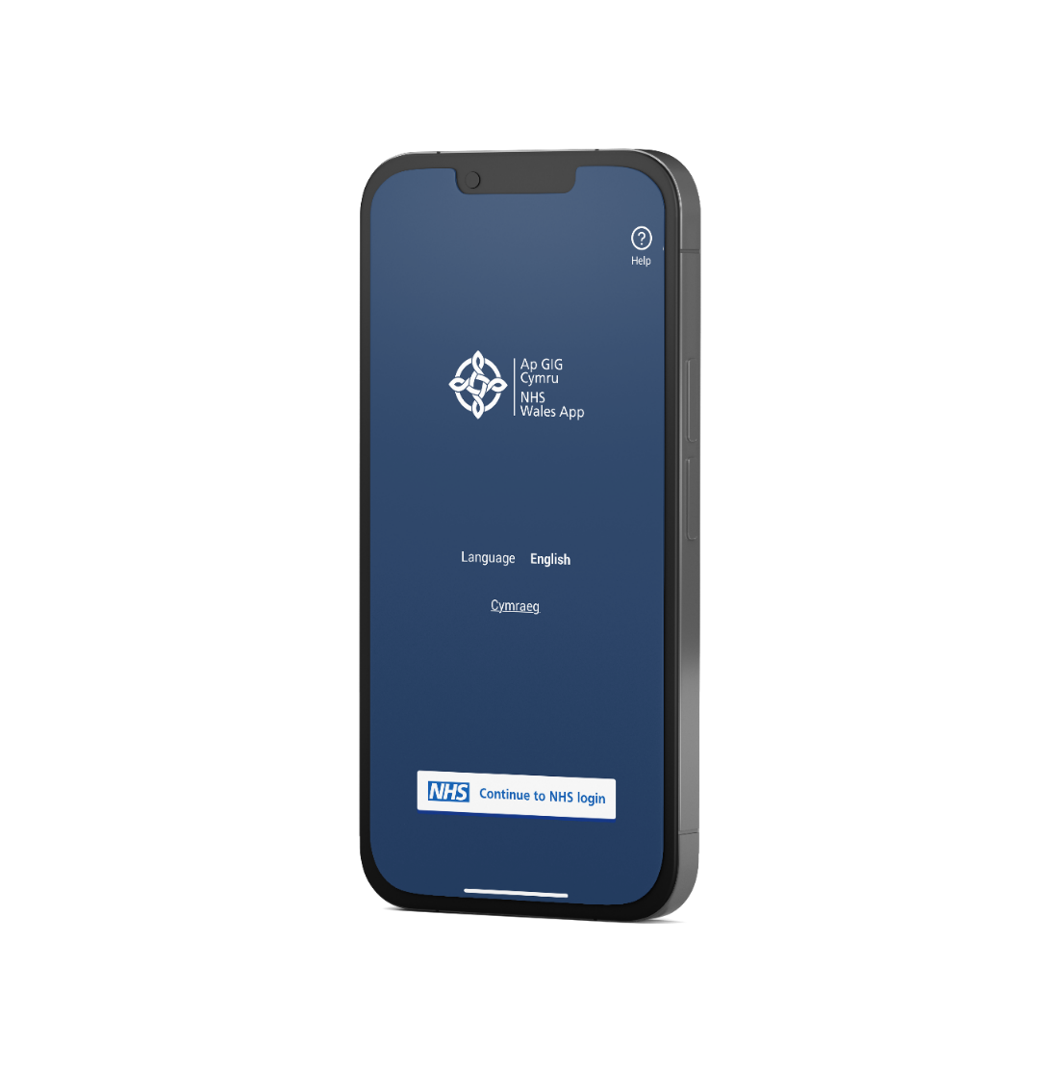

* The Welsh Identity Verification Service (WIVS) will enable patients and the public that do not possess photo ID to verify their identity at their local GP practice. Further information on this process will be provided in the coming weeks. WIVS has been developed and will be entering a beta testing phase with selected practices from 24th May for a number weeks.
* Proxy Access (Linked Profiles) – will enable patients of EMIS web practices only to book appointments, order repeat prescriptions, or view their GP health record on behalf of another patient within the same GP practice. This functionality will replace the level of functionality patients had in My Health Online, the current workaround for Cegedim practices will continue. Further information on this process will be provided in the coming weeks. Proxy Access will be entering a beta testing phase from mid-June 2024 for a number of weeks.

We are aware of patients receiving an error code starting with “3C” (i.e. *3c7u8j*) when using the NHS Wales App. As the App is still in public beta testing phase it is important for patient and the public to help us test the NHS Wales App before we release as a full launch.

These error codes can appear for several reasons which we are investigating with the software suppliers and are hoping to deliver a solution.

We are still encouraging patients who receive a 3c error message to report this via the in-App feedback mechanism which will help us in our investigation. Patients that have logged the issue using the in-App feedback mechanism will be contacted via email (if they have provided it) only when the issue is resolved.

DSPP have diligently continued to investigate the 3c error and the issue has been identified as being caused by a connected GP system. The supplier is committed to working with DSPP and have scheduled an update that is to be implemented by the end of May.

Kind regards,

Digital Services for Patients and the Public Team